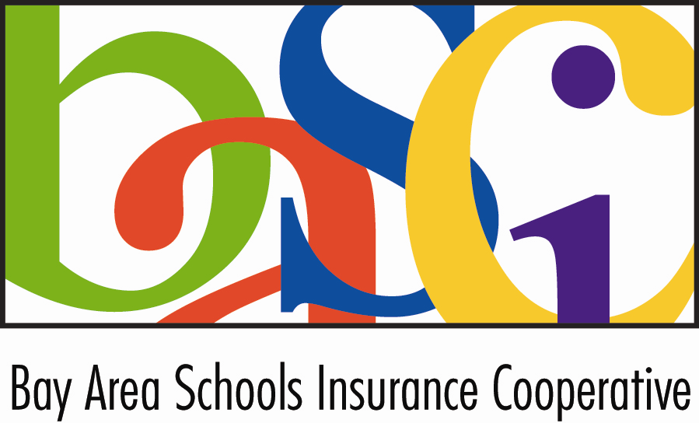

BAY AREA SCHOOLS INSURANCE COOPERATIVE
BOARD OF DIRECTORS MEETING
AGENDA

Wednesday, May 18, 2021
9:30 a.m.

Teleconference

This meeting will be held using the Zoom platform.

To join the meeting, please follow the instructions below:
- Click on the following link: (For best results, use Google Chrome as your browser.)
- https://us02web.zoom.us/j/88572064046?pwd=MUpxeXc5ODFNRDhrNlRZR252WGFYZz09

Audio Only: If you do not have internet access, you may join by phone by using the following information:
Meeting ID: 929 9150 8064
1 669 900 6833 US (San Jose)

All portions of this meeting will be conducted via teleconference in accordance with Government Code Section 54953(b). The teleconference locations are as follows: Sedgwick, 1750 Creekside Oaks Drive, Suite 200, Sacramento, CA;500 Cohassest Road, Suite 24, Chico, CA 95926;380 A Chadbourne Rd., Fairfield, CA 94534; 5760 Skylane Blvd, Suite 100, Windsor, CA 94592

Members of the public may participate in the meeting via Zoom or may listen to the meeting telephonically. Each location is accessible to the public, and members of the public may address the Board of Directors from any teleconference location.

In compliance with the Americans with Disabilities Act, if you need a disability-related modification or accommodation to participate in this meeting, please contact Lindsey Overton at (916) 244-1106 or lindsey.overton@sedgwick.com. Requests must be made as early as possible, and preferably at least one full business day before the start of the meeting.

Documents and materials relating to an open session agenda item that are provided to the BASIC Board less than 72 hours prior to a regular meeting will be available for public inspection. Please contact Lindsey Overton at (916) 244-1106 or lindsey.overton@sedgwick.com.

Page | - CALL TO ORDER
 | - INTRODUCTIONS
 | - APPROVAL OF AGENDA AS POSTED (OR AMENDED)
 | - PUBLIC COMMENTS – This time is reserved for members of the public to address the Board relative to matters of the Bay Area Schools Insurance Cooperative not on the agenda. Members of the public may submit comments by email in advance of the meeting by emailing Lindsey Overton at lindsey.overton@sedgwick.com no later than 5 p.m. on Monday, May 16, 2021. If a member of the public would like to address the Board during the meeting, the person may email Ms. Overton during the meeting and, if timely received, Ms. Overton will read or summarize the email to the directors. No action may be taken on non-agenda items unless authorized by law. Comments will be limited to five minutes per person and twenty minutes in total.
 | - REPORT FROM BOARD MEMBERS – This time is reserved for individual Board Members to report on items, issues, and changes in membership.
 | - CONSENT CALENDAR – If a Board Member would like to discuss any item listed, it may be pulled from the Consent Calendar.
 | *A. | Consideration of minutes from the April 11, 2022, Board of Directors meeting and the April 29, 2022 Special Meeting
 | *B. | Treasurer’s Report as of March 31, 2022
 | *C. | Cash Disbursement: April 1, 2022 – April 30, 2022
 | *D. | Resolution 01-2022 Establishing Meeting Dates for BASIC for the 2022/23 Program year
 |  | Recommendation: Approval of the Consent Calendar
 | - ADMINISTRATIVE MATTERS
 | *A. | Consideration of Resolution No. 02-2022 Board of Directors of BASIC expressing appreciation for the honorable service of Janet Selby
 |  |  | Recommendation: Staff recommends the Board Approve Resolution No. 02-2022
 | *B. | Consideration of Proposal from Sedgwick for General Administration Services  Recommendation: Staff will not be providing a recommendation on this item as Sedgwick has a financial interest in the outcome.
 | - COVERAGE MATTERS
 | A. | Update on Excess Liability and Crime Coverage for 2023/23
 |  |  | Recommendation: Discuss and provide direction to staff, as needed.
 | *B. | Consideration of BASIC Memorandum of Excess Liability Coverage for 2022/23
 |  |  | Recommendation: Staff recommends approval of the 2022 MOELC as presented, with direction to update the Summary of Coverage with the new coverage terms once approved.
 | - FINANCIAL MATTERS
 | *A. | Consideration of the Annual Operating Budget for the 2022/23 Program Year
 |  |  | Recommendation: Staff recommends approval of the Proposed Annual Operating Budget for the 2022/23 program year, subject to final numbers related to the excess placements.
 | - EXECUTIVE DIRECTOR’S REPORT
 | - CLOSING COMMENTS - This time is reserved for comments by the Board of Directors and/or staff and to identify matters for future Board of Directors business.
 | A. | Board of Directors
 | B. | Staff
 | - ADJOURNMENT
NOTICES:

- The next Board of Directors meeting will be held on Monday, November 15, 2022 at a location to be determined.

