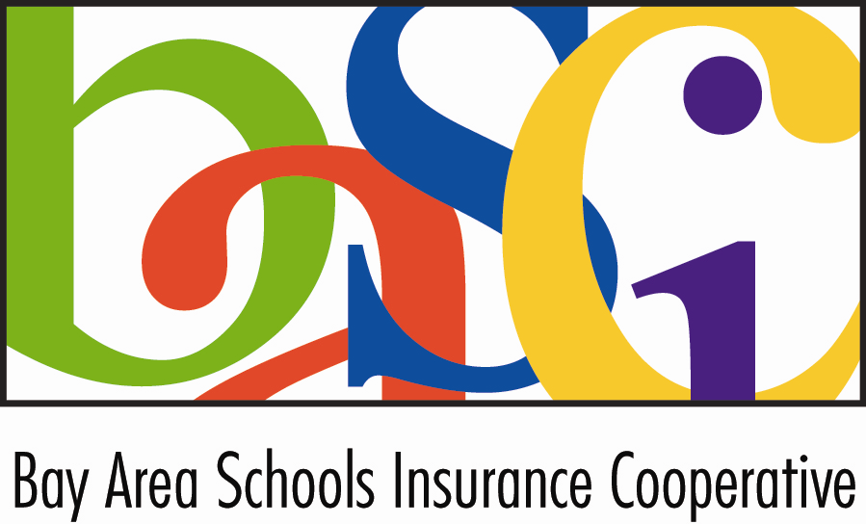

BAY AREA SCHOOLS INSURANCE COOPERATIVE
SPECIAL BOARD OF DIRECTORS MEETING
AGENDA

Tuesday, June 28, 2022
10:00 a.m.

Teleconference

This meeting will be held using the Zoom platform.

To join the meeting, please follow the instructions below:
- Click on the following link: (For best results, use Google Chrome as your browser.)
- https://us02web.zoom.us/j/81223127770?pwd=eW0ybUxXSm0xZTZucTY5NnUxaEMxQT09

Audio Only: If you do not have internet access, you may join by phone by using the following information:
Meeting ID: 932 8391 5325
1 669 900 6833 US (San Jose)

All portions of this meeting will be conducted via teleconference in accordance with Government Code Section 54953(b). The teleconference locations are as follows: Sedgwick, 1750 Creekside Oaks Drive, Suite 200, Sacramento, CA;500 Cohassest Road, Suite 24, Chico, CA 95926;380 A Chadbourne Rd., Fairfield, CA 94534; 5760 Skylane Blvd, Suite 100, Windsor, CA 94592

Members of the public may participate in the meeting via Zoom or may listen to the meeting telephonically. No physical location will be available from which members may observe the meeting and offer public comment. Public comments may be submitted in advance of the meeting by emailing Lindsey Overton at lindsey.overton@sedgwick.com no later than 5:00 p.m. on Thursday, April 28, 2022. If a member of the public would like to address the Board during the meeting, the person may email Ms. Overton during the meeting and, if timely received, Ms. Overton will read or summarize the email to the directors.

In compliance with the Americans with Disabilities Act, if you need a disability-related modification or accommodation to participate in this meeting, please contact Lindsey Overton at (916) 705-2057 or lindsey.overton@sedgwick.com. Requests must be made as early as possible, and preferably at least one full business day before the start of the meeting.

sBoard less than 72 hours prior to a regular meeting will be available for public inspection. Please contact Lindsey Overton at (916) 705-2057or lindsey.overton@sedgwick.com.

Page | - CALL TO ORDER
 | - INTRODUCTIONS
 | - APPROVAL OF AGENDA AS POSTED (OR AMENDED)
 | - PUBLIC COMMENTS – This time is reserved for members of the public to address the Board relative to matters of the Bay Area Schools Insurance Cooperative not on the agenda. Members of the public may submit comments by email in advance of the meeting by emailing Lindsey Overton at lindsey.overton@sedgwick.com no later than 5 p.m. on Thursday, April 28, 2022. If a member of the public would like to address the Board during the meeting, the person may email Ms. Overton during the meeting and, if timely received, Ms. Overton will read or summarize the email to the directors. No action may be taken on non-agenda items unless authorized by law. Comments will be limited to five minutes per person and twenty minutes in total.
 | - REPORT FROM BOARD MEMBERS – This time is reserved for individual Board Members to report on items, issues, and changes in membership.
 | - CONSENT CALENDAR - If a Board Member would like to discuss any item listed, it may be pulled from the Consent Calendar.
 | *A. | Meeting Minutes of the May 18, 2022, Board of Directors Meeting.
 | *B. | Interim Financial Statements as of March 31, 2022
 | *C. | Cash Disbursement: May 1, 2022 - May 31, 2022
 | *D. | Investment Policy 2.3 Revised June 28, 2022
 |  |  | Recommendation: Approval of Consent Calendar.
 | - ADMINISTRATIVE MATTERS
 | *A. | Brokerage Report
 |  |  | Recommendation: None.
 | *B. | Consideration of Proposal from Sedgwick for General Administration Services  Recommendation: Staff will not be providing a recommendation on this  item as Sedgwick has a financial interest in the outcome.
 | *C. | Consideration of the Provision of Actuarial Services for BASIC  Recommendation: Provide direction to staff on whether to negotiate a  renewal with AON or disseminate a request for proposals.
 | - FINANCIAL MATTERS
 | *A. | Consideration of the Annual Operation Budget for the 2022/23 Program Year
 |  |  | Recommendation: Staff recommends approval of the Proposed Annual Operating Budget for the 2022/23 program year, subject to final numbers related to the excess liability and cyber placements.
 | - CLOSING COMMENTS - This time is reserved for comments by the Board of Directors and/or staff and to identify matters for future Board of Directors business.
 | A. | Board of Directors
 | B. | Staff
 | - ADJOURNMENT
NOTICES:
- The next Board of Directors Meeting will be held on Tuesday, November 15, 2022

